Lab 2: Constructors, the this Keyword and static Members
Exercise 1: Creating a Car Class
Student Name: Jichichi Clive T
Registration Number: H250254B
Programme: Software Engineering
Date: 8/10/2026
Exercise 1: Circle Class with Overloaded Constructors
Aim: To demonstrate constructor overloading in Java.
Source Code
Circle.java
// Represents a circle using its radius
public class Circle {

// Stores the radius of the circle
double radius;

// No-argument constructor sets the default radius
public Circle() {
radius = 1.0;
}

// Constructor accepts a specified radius
public Circle(double radius) {
this.radius = radius;
}

// Calculates the area of the circle
public double area() {
return Math.PI * radius * radius;
}

// Displays the circle's radius and area
public void display() {
System.out.println("Radius: " + radius);
System.out.println("Area: " + area());
System.out.println("--------------------");
}
}
Main.java
// Tests the Circle class and its constructors
public class Main {

public static void main(String[] args) {

// Uses the no-argument constructor
Circle circle1 = new Circle();

// Uses the constructor that accepts a radius
Circle circle2 = new Circle(5.0);

// Displays the details of both circles
System.out.println("Default Circle:");
circle1.display();

System.out.println("Circle with Custom Radius:");
circle2.display();
}
}
Output
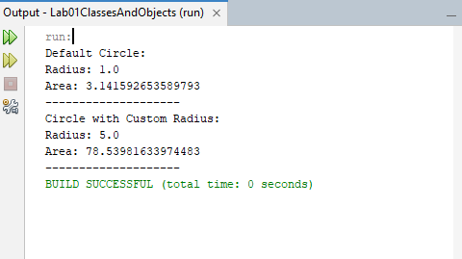
Explanation: The Circle class has two constructors. The no-argument constructor assigns a radius of 1.0, while the parameterized constructor accepts a radius from the user.
Conclusion: The exercise demonstrated how constructor overloading allows objects to be initialized in different ways.

Exercise 2: Static Counter in the Circle Class
Aim: To use a static variable to count the number of Circle objects created.
Source Code
Circle.java
// Represents a circle and counts the circles created
public class Circle {

// Stores the radius for each individual circle
double radius;

// Shared counter belonging to the Circle class
private static int circleCount = 0;

// No-argument constructor sets radius to 1.0
public Circle() {
radius = 1.0;
circleCount++;
}

// Constructor accepts a specified radius
public Circle(double radius) {
this.radius = radius;
circleCount++;
}

// Static getter returns the number of circles created
public static int getCircleCount() {
return circleCount;
}

// Calculates the area of the circle
public double area() {
return Math.PI * radius * radius;
}

// Displays the circle's radius and area
public void display() {
System.out.println("Radius: " + radius);
System.out.println("Area: " + area());
System.out.println("--------------------");
}
}
Main.java
// Tests circle constructors and the static counter
public class Main {

public static void main(String[] args) {

// Creates three Circle objects
Circle circle1 = new Circle();
Circle circle2 = new Circle(5.0);
Circle circle3 = new Circle(3.0);

// Displays each circle's details
circle1.display();
circle2.display();
circle3.display();

// Gets the total number of circles created
System.out.println("Total circles created: "
+ Circle.getCircleCount());
}
}
Output
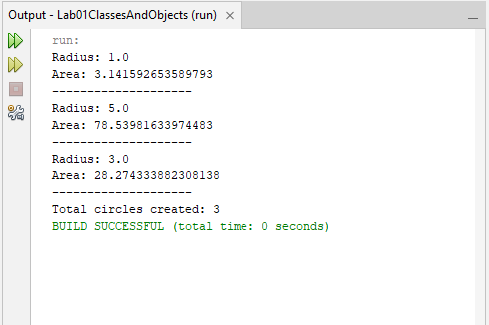
Explanation: The static variable circleCount is shared by all Circle objects. Each constructor increments the counter, and the static getter getCircleCount() returns the total.
Conclusion: The exercise demonstrated how static members can store and retrieve information shared across objects of the same class.

Exercise 3: Employee Class with Overloaded Constructors
Aim: To demonstrate constructor overloading, copy constructors, and automatic ID generation in Java.
Source Code
Employee.java
// Represents an employee with a unique automatically assigned ID
public class Employee {

// Static counter shared by all Employee objects
private static int nextEmployeeId = 1;

// Instance fields store each employee's information
private int employeeId;
private String name;
private String department;
private double salary;

// Assigns the next available ID to each new employee
private void assignEmployeeId() {
employeeId = nextEmployeeId;
nextEmployeeId++;
}

// Constructor 1: Creates an employee with default details
public Employee() {
assignEmployeeId();
name = "Unknown";
department = "Unassigned";
salary = 0.0;
}

// Constructor 2: Accepts the employee's name
public Employee(String name) {
assignEmployeeId();
this.name = name;
department = "Unassigned";
salary = 0.0;
}

// Constructor 3: Accepts name, department and salary
public Employee(String name, String department, double salary) {
assignEmployeeId();
this.name = name;
this.department = department;
this.salary = salary;
}

// Copy constructor creates a new employee using another employee's details
public Employee(Employee other) {
assignEmployeeId();
this.name = other.name;
this.department = other.department;
this.salary = other.salary;
}

// Displays employee information
public void display() {
System.out.println("Employee ID: " + employeeId);
System.out.println("Name: " + name);
System.out.println("Department: " + department);
System.out.println("Salary: $" + salary);
System.out.println("--------------------");
}
}
Main.java
// Tests Employee constructors and automatic ID assignment
public class Main {

public static void main(String[] args) {

// Uses the no-argument constructor
Employee employee1 = new Employee();

// Uses the constructor that accepts a name
Employee employee2 = new Employee("Tendai");

// Uses the constructor that accepts all employee details
Employee employee3 =
new Employee("Rudo", "IT", 1200.00);

// Copies employee3's details into a new employee with a new ID
Employee employee4 = new Employee(employee3);

// Displays the details of all employees
employee1.display();
employee2.display();
employee3.display();
employee4.display();
}
}
Output
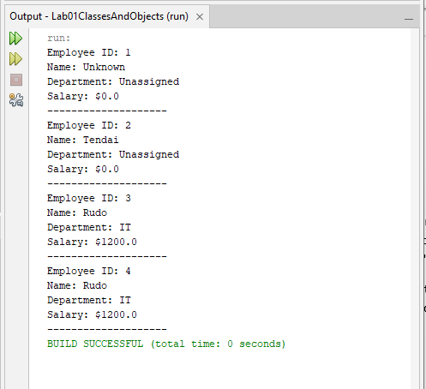
Explanation: The Employee class uses a static counter to assign a unique ID whenever an employee is created. Three overloaded constructors initialize employees in different ways, while the copy constructor copies an existing employee's details and assigns a new ID.
Conclusion: The exercise demonstrated how constructors support different object initialization options and how static variables can generate unique employee IDs.

Exercise 4: Static and Instance Initialization Blocks
Aim: To investigate the execution order of static blocks, instance blocks, and constructors in Java.
Source Code
// Demonstrates the execution order of initialization blocks
public class InitializationDemo {

// First static block runs once when the class is loaded
static {
System.out.println("First static block");
}

// Second static block also runs once when the class is loaded
static {
System.out.println("Second static block");
}

// First instance block runs whenever an object is created
{
System.out.println("First instance block");
}

// Second instance block runs after the first instance block
{
System.out.println("Second instance block");
}

// Constructor runs after the instance initialization blocks
public InitializationDemo() {
System.out.println("Constructor");
}

// Main method starts the program
public static void main(String[] args) {

// Creates the first object
System.out.println("Creating first object:");
InitializationDemo obj1 = new InitializationDemo();

// Creates the second object
System.out.println("Creating second object:");
InitializationDemo obj2 = new InitializationDemo();
}
}
Output
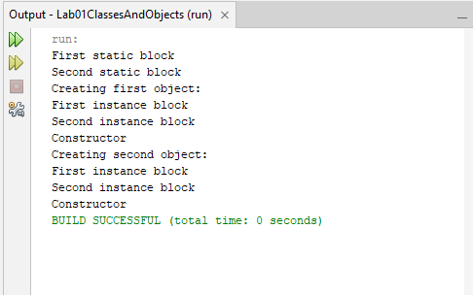
Explanation: Static blocks execute once when the class is initialized. Instance blocks execute whenever an object is created, in their order of appearance, followed by the constructor.
Conclusion: The exercise demonstrated that Java executes static initialization before object creation and runs instance initialization blocks before the constructor for each new object.

Exercise 5: Temperature Class with Static Factory Methods
Aim: To implement static factory methods for creating temperature objects from Celsius and Fahrenheit values.
Source Code
Temperature.java
// Represents temperature internally in Celsius
public class Temperature {

// Stores the temperature in Celsius
private double celsius;

// Private constructor prevents direct object creation from outside
private Temperature(double celsius) {
this.celsius = celsius;
}

// Factory method creates a Temperature from Celsius
public static Temperature fromCelsius(double celsius) {
return new Temperature(celsius);
}

// Factory method converts Fahrenheit to Celsius before creating an object
public static Temperature fromFahrenheit(double fahrenheit) {
double celsius = (fahrenheit - 32) * 5.0 / 9.0;
return new Temperature(celsius);
}

// Returns the temperature in Celsius
public double getCelsius() {
return celsius;
}

// Converts Celsius to Fahrenheit and returns the result
public double getFahrenheit() {
return (celsius * 9.0 / 5.0) + 32;
}

// Displays the temperature in both units
public void display() {
System.out.printf("Celsius: %.2f°C%n", getCelsius());
System.out.printf("Fahrenheit: %.2f°F%n", getFahrenheit());
System.out.println("--------------------");
}
}
Main.java
// Tests the Temperature class and its factory methods
public class Main {

public static void main(String[] args) {

// Creates a temperature using Celsius
Temperature temp1 = Temperature.fromCelsius(25.0);

// Creates a temperature using Fahrenheit
Temperature temp2 = Temperature.fromFahrenheit(98.6);

// Displays both temperature objects
System.out.println("Temperature created from Celsius:");
temp1.display();

System.out.println("Temperature created from Fahrenheit:");
temp2.display();
}
}
Output
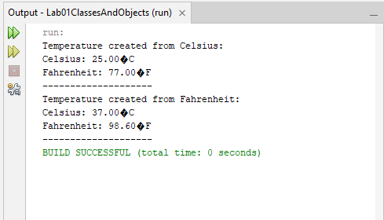
Explanation: The private constructor prevents direct object creation from outside the class. The static factory methods clearly identify the input temperature unit and convert Fahrenheit to Celsius when necessary. Static factory methods are clearer than overloaded constructors because their names explain how each object is created.
Conclusion: The exercise demonstrated how static factory methods provide a clear and controlled way to create objects while keeping temperature conversion logic within the class.

